|  |  |  |
| --- | --- | --- |
| **VI SHNU V** | | |
| **F U L L S T A C K** | | **D E V E L O P E R** |
|  | +91 8714413794 | |

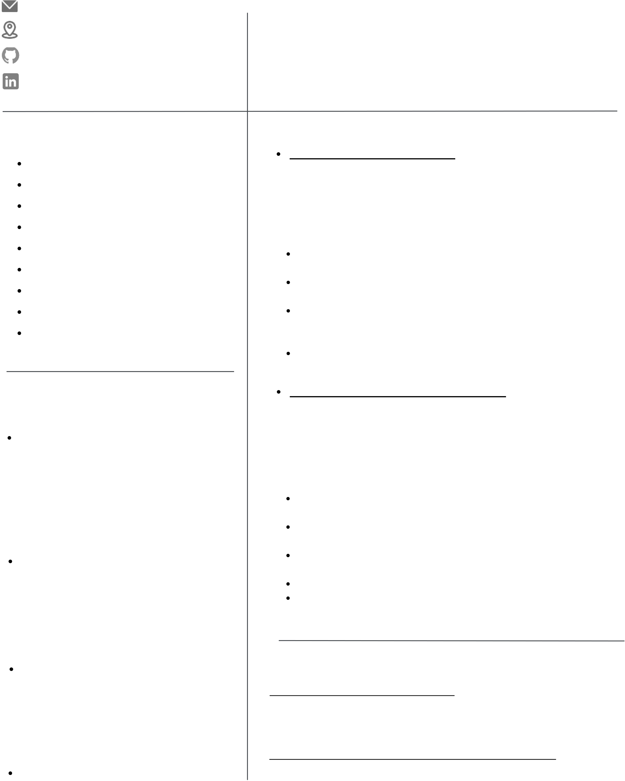

[vishnusathyanathan](mailto:vishnuvv@mail.com)@gmail.com Bangalore, India

Highly motivated and self-taught full-stack developer with a passion for problem-solving and creating innovative web applications. Proven track record of success in learning and mastering new

|  |  |  |
| --- | --- | --- |
|  | github.com/vishnuvvv | technologies on my own. Seeking a challenging role as a MERN |
| stack developer where I can utilize my skills and continue to grow |
| linkedin.com/in/vishnu-v-0789/ |
| and learn while making a positive impact on the company and its |

clients.

|  |  |
| --- | --- |
| **S K I L L S**  **NODE**  **EXPRESS**  **MONGODB**  **REACT**  **JAVASCRIPT**  **HTML**  **CSS**  **GIT,GIT HUB** | **P E R S O N A L P R O J E C T S**   **BLOG- APP( MERN- STACK)**   **DeploymentLink :-blogeat.onrender.com**   **Git hubLink (front-end):-github.com/vishnuvvv/Frontend-Blog-**  **App**   **Git hubLink (back-end):-github.com/vishnuvvv/Backend-** **Blog-App**  Technologies Used :-Node JS, Express JS,Mongo DB, React JS, Material UI  Libraries Used :-bcrypt, Jwt, axios, dotenv, redux, cors, Nodemon, Mongoose,Material UI icon, React-router-dom  It's a social media platform multiple users can create account and |

**BOOT STRAP ,MUI(BASICS)**

people can publish their blogs also they can update and remove the existing blogs   
front end form validation added and authentication added using redux

**BOOK STORE APP ( MERN- STACK)**

**E D U C A T I O N**  **Deployment Link :- storebooks.onrender.com**

**POST GRADUATION**

Nehru arts and science college Coimbatore(Tamilnadu)

**Course : M.sc. Electronics and communication systems**   
2016-2018

**GRADUATION**

Gems Arts And Science College (Malappuram,Kerala)

**Course : B.sc. Electronics** 2013-2016

**PLUS TWO**

GVHS School Makkaraparamba (Malappuram,Kerala)

**Course : Science**   
2011-2013

**SSLC(10th)**

GVHS School Makkaraparamba (Malappuram,Kerala)   
2011

**Git hubLink (front-end):-github.com/vishnuvvv/Bookstore-**

**app-frontend**

**Git hubLink (front-end):-github.com/vishnuvvv/Bookstore-**

**app-backend**

Technologies used :-Node JS, Express JS,Mongo DB, React JS, Material UI   
Libraries used :-Axios, Nodemon , Mongoose, Material UI icon, React-router-dom   
Using this app we can store delete update the book info, basic crud operations writen here.

Backend server implemented using node express to serve APIs Front- end designed using Mterial UI and react-router-dom is used to move into different routes

**E X P E R I E N C E**   
**ROLE : - STUDENT TRAINEE**   
10x Accademy (07/2019 - Present)

Currently pursuing full stack development boot camp in 10x- accademy

**ROLE : - CONTENT ANALYST**   
Bytedance India pvt ltd (Tik-tok) (02/2019 - 09/2022)

I have experience in different content moderation projects with deep knowledge of policy guidelines and have good proficiency in MS Excel. During this work period, I highlighted critical cases in the platform to the higher authorities, which helped the firm to remove them and avoid product risk.